CREATE TABLE student.tblParents (

parent_id Int,

parent_name varchar(50),

city varchar(50),

age Int,

annual_income Int,

occupation varchar(50),

emailid varchar(50),

PRIMARY KEY (parent_id)

);

INSERT INTO Student.tblParents (parent_id, parent_name, city, age, annual_income, occupation, emailid) VALUES

(1, 'jay', 'Pune', 45, 800000, 'Teacher', 'jayjay@gmail.com'),

(2, 'veeru', 'Mumbai', 38, 500000, 'Engineer', 'veerveeru@gmail.com'),

(3, 'Thakur', 'Nagpur', 50, 900000, 'Police', 'policethakur@gmail.com'),

(4, 'Gabbar', 'Nagar', 42, 700000, 'Daku', 'daku@gmail.com'),

(5, 'Rudra', 'Ichalkaranji', 35, 550000, 'Teacher', 'rudra12@gmail.com'),

(6, 'Sachin', 'Mumbai', 47, 650000, 'Cricketer', 'sachin11@gmail.com'),

(7, 'Rohit', 'Shegaon', 55, 1000000, 'Gardner', 'rooo@gmail.com'),

(8, 'Karan', 'Pandharpur', 40, 600000, 'Trusty', 'karunnn@gmail.com'),

(9, 'Pyaremohan', 'Dombivali', 48, 750000, 'TC', 'humpyare@gmail.com'),

(10, 'pathan', 'nashik', 41, 850000, 'Sarpanch', 'npathan@gmail.com'),

(11, 'Dagdu', 'Malegaon', 44, 650000, 'Driver', 'tufandagdu@gmail.com'),

(12, 'Suresh', 'Parbhani', 39, 500000, 'Writer', 'suuuresh@gmail.com'),

(13, 'Ravi', 'Fursungi', 52, 800000, 'Devloper', 'rawee@gmail.com'),

(14, 'Hanmant', 'Buldhana', 37, 550000, 'Graphic Designer', 'stylishhanmant@gmail.com'),

(15, 'Mera', 'Bhandara', 46, 900000, 'Contracter', 'mera34@gmail.com'),

(16, 'Astha', 'Shirdi', 43, 700000, 'Doctor', 'asthahere@gmail.com'),

(17, 'Arambh', 'Gadchiroli', 36, 450000, 'Police', 'arambh1234@gmail.com'),

(18, 'Jetha', 'Mumbai', 49, 750000, 'Buisnessman', 'jetha68@gmail.com'),

(19, 'Mukesh', 'Beed', 53, 950000, 'Actor', 'vmukesh@gmail.com'),

(20, 'Deviprasad', 'Pune', 42, 600000, 'Real Estate', 'devi73@gmail.com');

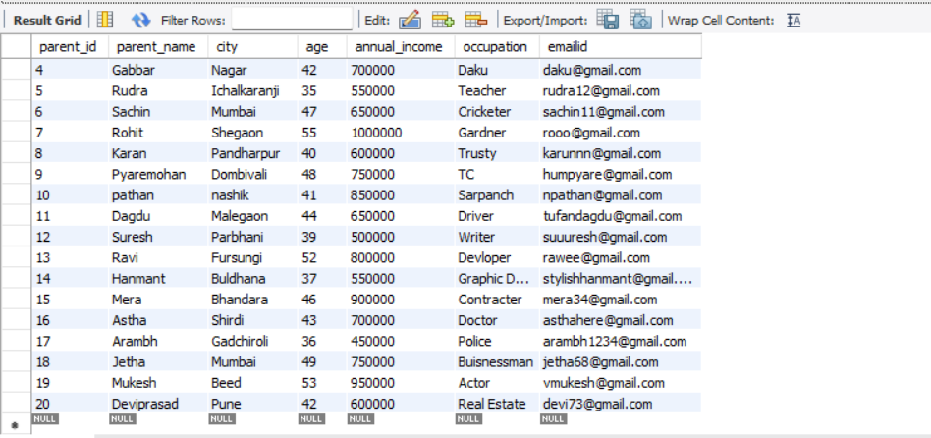

UPDATE Student.tblParents SET emailid = 'NA';

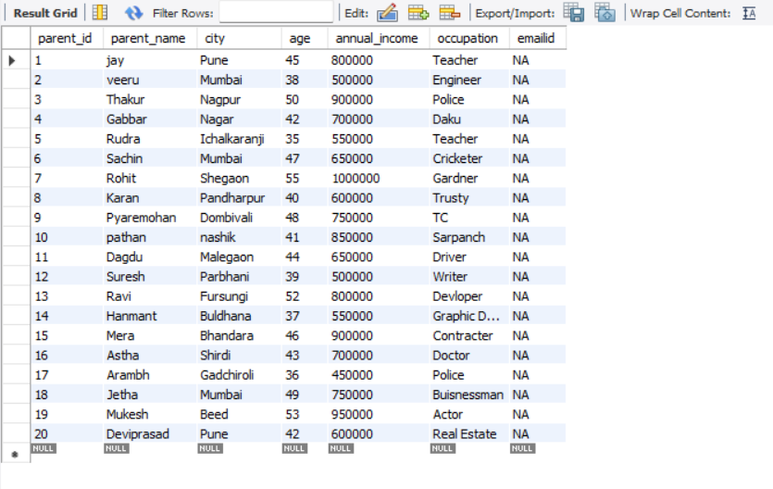

SELECT COUNT(*) FROM Student.tblParents WHERE annual_income > 600000;



SELECT * FROM Student.tblParents WHERE city IN ('Shirdi', 'Pune', 'Mumbai', 'Chennai', 'Nagpur');

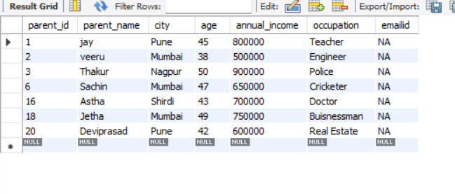

SELECT * FROM Student.tblParents WHERE annual_income < 500000;

